Project Design Phase-II

Data Flow Diagram & User Stories

|  |  |
| --- | --- |
| Date | 08 november 2022 |
| Team ID | PNT2022TMID04163 |
| Project Name | statistical machine learning approach to liver disease prediction |
| Maximum Marks | 4 Marks |

# Data Flow Diagrams:

A Data Flow Diagram (DFD) is a traditional visual representation of the information flows within a system. A neat and clear DFD can depict the right amount of the system requirement graphically. It shows how data enters and leaves the system, what changes the information, and where data is stored.

# Example: [(Simplified)](https://developer.ibm.com/patterns/visualize-unstructured-text/)

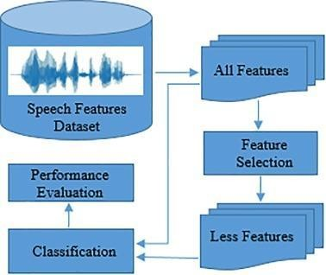 

# User Stories

Use the below template to list all the user stories for the product.

|  |  |  |  |  |  |  |
| --- | --- | --- | --- | --- | --- | --- |
| **User Type** | **Functional Requirement (Epic)** | **User Story Number** | **User Story / Task** | **Acceptance criteria** | **Priority** | **Release** |
| Customer (Mobile user) | Registration | USN-1 | As a user, I can register for the application by entering my email, password, and confirming  my password. | I can access my account / dashboard | High | Sprint-1 |
|  |  | USN-2 | As a user, I will receive confirmation email once I have registered for the application | I can receive confirmation email & click confirm | High | Sprint-1 |
|  |  | USN-3 | As a user, I can register for the application  through Facebook | I can register & access the  dashboard with Facebook Login | Low | Sprint-2 |
|  |  | USN-4 | As a user, I can register for the application  through Gmail |  | Medium | Sprint-1 |
|  | Login | USN-5 | As a user, I can log into the application by  entering email & password |  | High | Sprint-1 |
|  | Dashboard |  |  |  |  |  |
| Customer (Web user) |  |  |  |  |  |  |
| Customer Care  Executive |  |  |  |  |  |  |
| Administrator |  |  |  |  |  |  |
|  |  |  |  |  |  |  |
|  |  |  |  |  |  |  |
|  |  |  |  |  |  |  |